1. How do you change your own user account password? DON'T change the server root password.
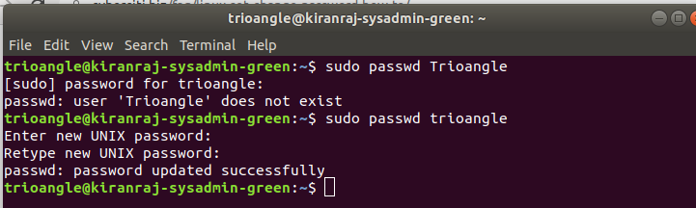

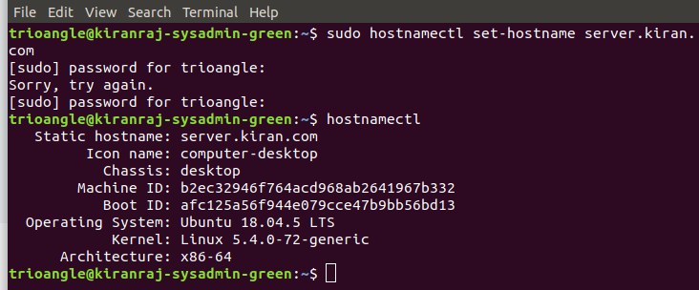
2. How do you change the hostname on your server? Change the server hostname as Ex: server.yourname.com

3. Find HDD Capacity and usage with df command and provide an output
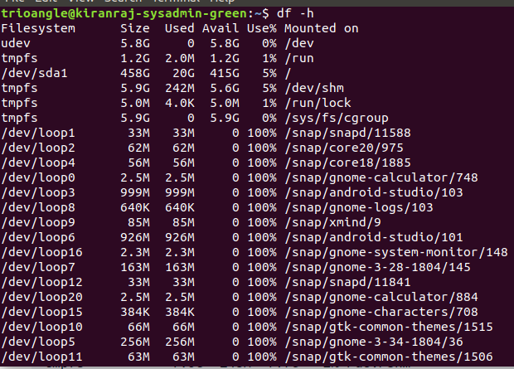
sudo dpkg-query -f '${binary:Package}\n' -W > packages_list.txt
Identity file ec2instancedemokey.pem not accessible: No such file or directory.

sudo dpkg-query -f '${binary:Package}\n' -W > packages_list.txt

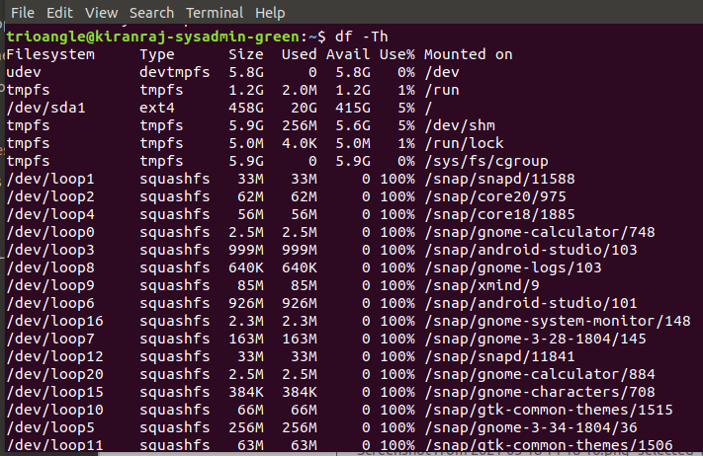
4. Find out the file system type using "df and mount command" and provide an output.

Trioangle164%^&(*

5. How much memory is your system using currently?
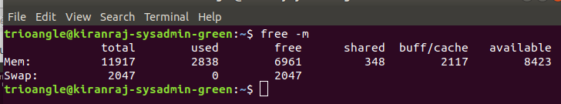

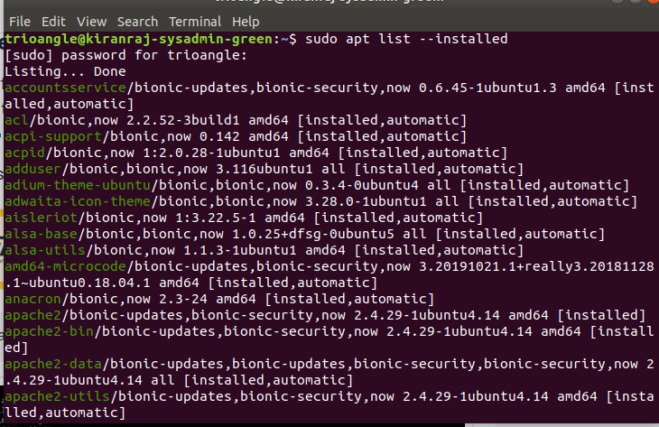

6. Find out the installed packages list on your system

a.sudo apt list --installed | grep screen ?
Ans: To find out whether a specific package
is installed

b.sudo dpkg-query -l | less ?
Ans: The command will show you a list of all installed packages
including the packages versions (installl with dpkg)

c.sudo dpkg-query -f '${binary:Package}\n' -W | wc -l
ans: To find out how many packages are installed on your system you can use the same command
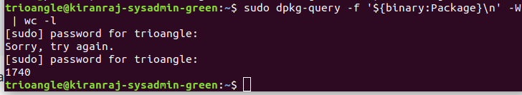

7. Find out the Package Name and information

You need to use the apt or apt-get or dpkg command to list all installed packages
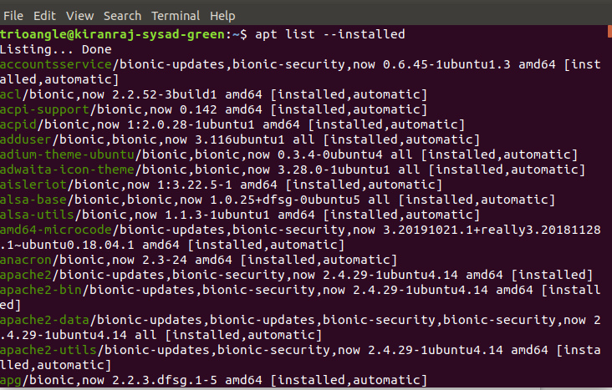

8. How do you install packages "rsync, wget and screen" using yum command?

Rsync, is a free command-line tool that lets you transfer files and directories to local and remote destinations
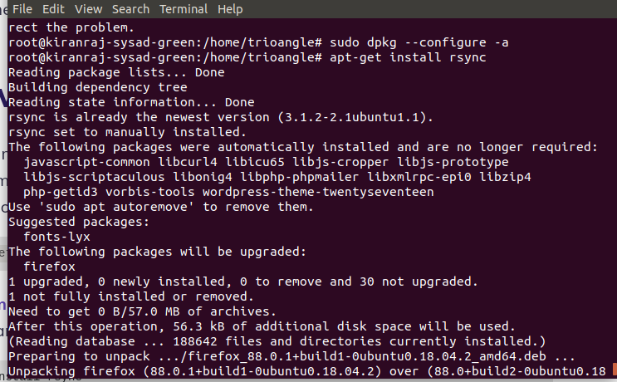
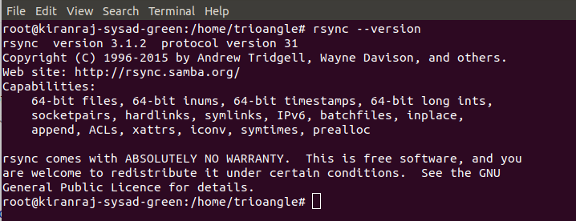

9. How do you remove packages "rsync, wget and screen" using yum command?

sudo apt-get remove rsync
sudo apt-get remove --auto-remove rsync
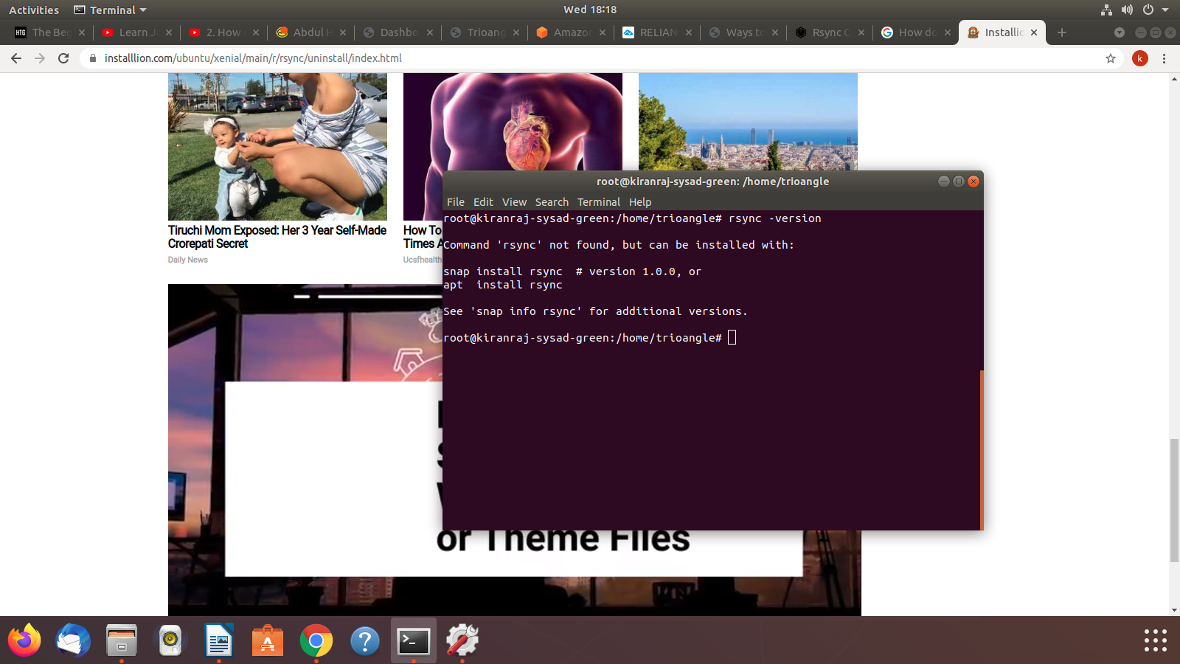

10. Create a directory called "your name" under "/" partition Ex:/yourname and upload some Files within your own directory from your local PC to your server.

a) direcrtory name kiranraj.txt has been created b) opened EC2 instance in local machine
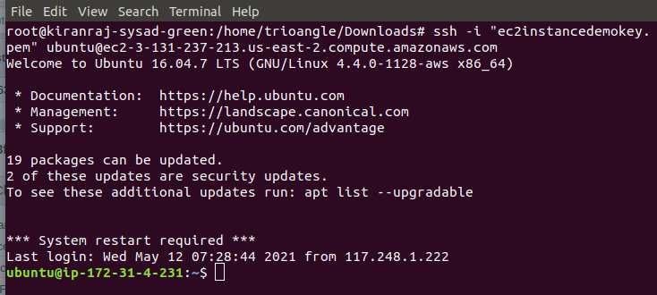
in Download folder
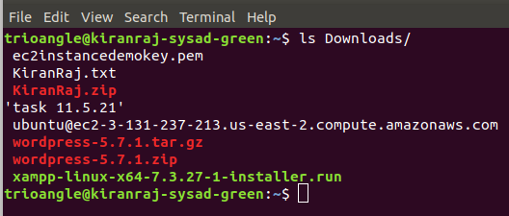

c) using ls command in ec2 instance by verifiying d) using scp -i command copy the particular directory or file
file not exist in ec2 machine to the ec2 instance
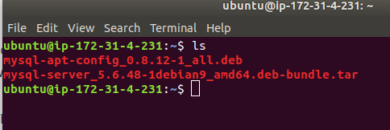
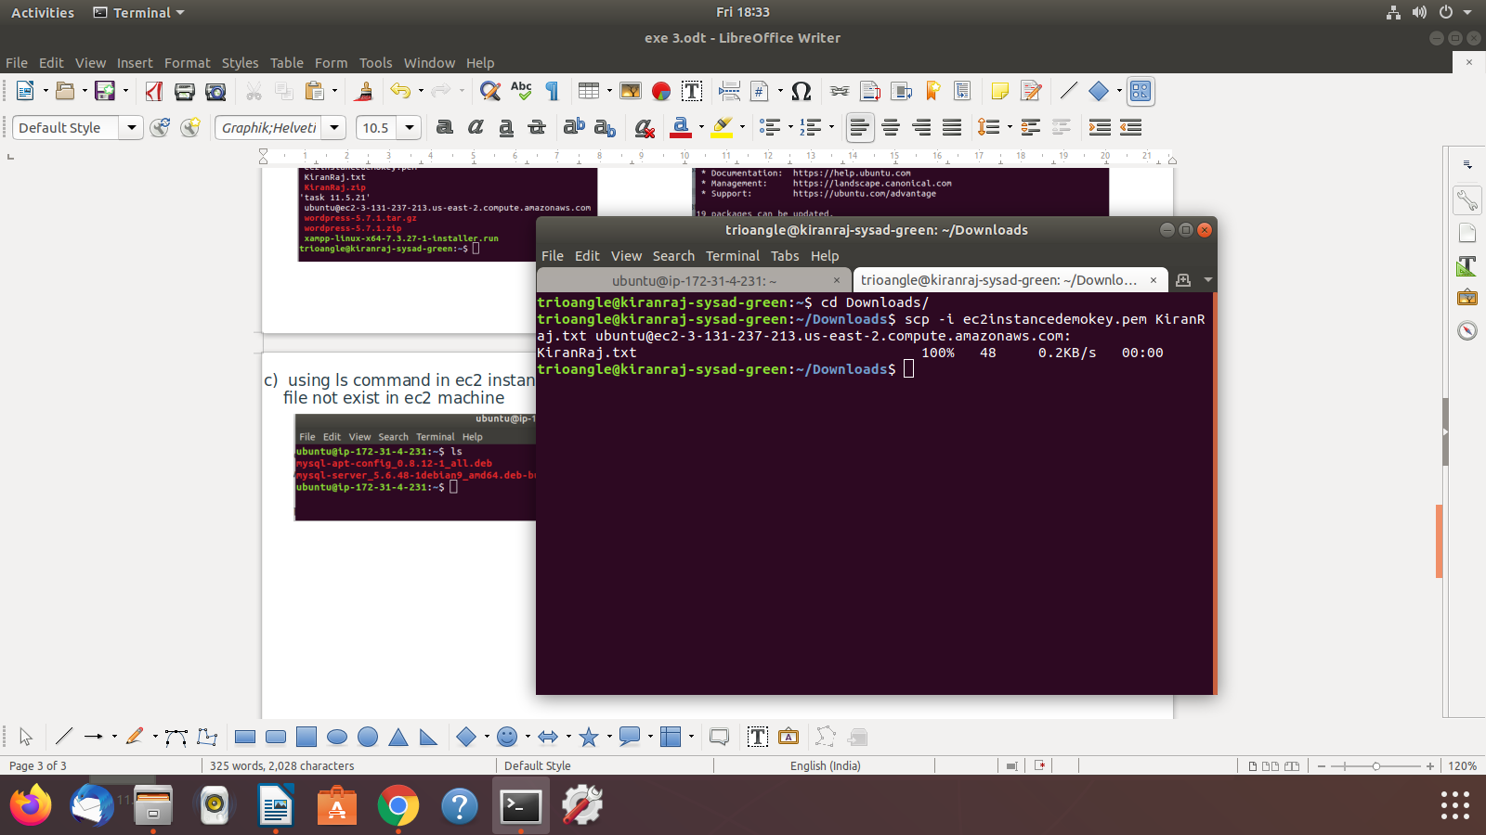

e) the file has been copied to the ec2 instance f) now check whether file has been copied to instance
or not using ls command
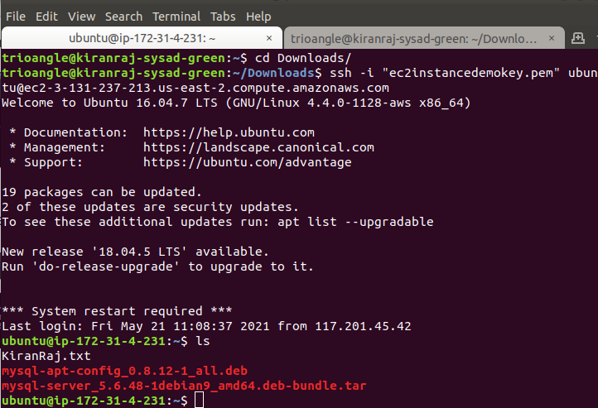

g) hence file copied to the instanceTrioangle164%^&(*

